BSE4104: Emerging Trends in Software Engineering
Week 2 Capstone Deliverable
GROUP H
Prompt Specification and Version Iteration Record
System: ProcureCheck, Public Procurement Document-Completeness Agent
Course & Institution | BSE4104, Makerere University (CoCIS)
Lead Student / Developer | Makmot Kabira Johnson (BSc Software Engineering, Year IV)
Project Title | ProcureCheck, Public Procurement Document-Completeness Verification Agent
Week 2 Task Covered | Versioning of at least two meaningful prompt iterations
Reference Document | Week 1: Primary User Profile and End-to-End Workflow Specification
Status | Draft prepared for BSE4104 capstone submission, Week 2

1. Context and Link to Week 1
The Week 1 deliverable set out who Procure Check is built for and what the system does end to end: a Procurement Officer uploads a bidder's tender submission, the system indexes it, and a bounded agent works through a PPDA checklist item by item, flagging what is present, missing, or ambiguous, with every finding traceable to a page. The officer then reviews and signs off, since the agent has no authority to disqualify a bidder or make an award decision.
This document picks up at Stage 3 of that workflow, agentic completeness scrutiny, which is the point where the agent has to reason about a single checklist requirement and decide, from retrieved text, whether it is satisfied. That reasoning is driven entirely by a prompt. Getting that prompt right, and being able to show how it improved, is the focus of this Week 2 deliverable.
Rather than covering every Week 2 requirement, this document is scoped to one specific task: producing at least two meaningful, versioned iterations of the prompt that governs checklist verification, along with the testing that justified moving from one version to the next.

2. Where This Prompt Sits in the System
For each checklist item, such as “valid URA tax clearance certificate,” the agent first calls a retrieval tool (locate_clause) to pull the most relevant passages from the indexed tender document. Those passages, together with the checklist requirement itself, are passed into the prompt covered in this document. The model's job at that point is narrow: decide whether the requirement is met, partially met, or not met, using only the retrieved text, and explain why in a way the officer can check against the source page.
Because this output feeds directly into a report an officer will sign off on, vague or inconsistent phrasing is not just an inconvenience, it is a compliance risk. That is the main thing the two prompt versions below were trying to fix.

3. Prompt Version 1.0 (Initial Draft)
The first version was written to get something working quickly, mainly to confirm that the retrieval step and the model call were wired together correctly. It states the role and task, but leaves the output format, the handling of missing evidence, and the citation requirement all implicit.
ROLE
You are a procurement compliance assistant helping check tender documents.

TASK
Look at the checklist requirement and the document text below, and say whether the
requirement is met.

CHECKLIST REQUIREMENT: {requirement_text}
DOCUMENT TEXT: {retrieved_passages}

Answer with your assessment.

3.1 Testing v1.0
This version was run against a small batch of checklist items pulled from three synthetic tender submissions, covering documents that were clearly present, clearly absent, and partially present (for example, a certificate that had expired). Three problems showed up consistently enough to justify a revision rather than a small patch:
- Inconsistent output shape. Sometimes the model returned a short sentence, sometimes a paragraph, sometimes a bulleted list. None of these could be parsed reliably into the structured report described in the Week 1 workflow.
- No page reference. Even when the model correctly identified that a document was present, it did not reliably repeat the page number back, which defeats the traceability requirement that the officer relies on to sign off quickly.
- Guessing under uncertainty. When the retrieved passages did not clearly answer the question, the model tended to assume the document was present rather than saying so honestly. For a compliance tool, an unjustified pass is worse than an unclear result, since it hides risk from the officer instead of surfacing it.

4. Prompt Version 2.0 (Revised)
The second version keeps the same underlying task but closes the three gaps found in testing. It adds a stated boundary on the model's authority (matching the Week 1 boundary matrix, where the agent is never the one making a pass or fail call), forces a fixed JSON output so the report generator in Stage 5 of the workflow can parse it directly, and makes the page reference mandatory rather than optional.
ROLE
You are a compliance verification assistant supporting a procurement officer during
the preliminary examination of a tender submission. You do not make pass or fail
decisions. You report evidence so a human officer can decide.

TASK
Given one checklist requirement and the document passages retrieved for it, decide
whether the requirement is PRESENT, MISSING, or AMBIGUOUS, using only the passages
provided. Do not use outside knowledge of procurement law and do not assume a
document exists if it is not in the passages.

CHECKLIST REQUIREMENT: {requirement_text}
DOCUMENT PASSAGES: {retrieved_passages}
(each passage is tagged with its page number)

OUTPUT FORMAT (JSON only, no extra text):
{
"status": "PRESENT | MISSING | AMBIGUOUS",
"page_reference": "page number(s) the finding is based on, or null",
"evidence_snippet": "short quote or paraphrase from the passages, or null",
"explanation": "one or two sentences an officer can check quickly",
"confidence": "high | medium | low"
}

FAILURE BEHAVIOUR
If the passages do not contain enough information to decide, return status
AMBIGUOUS with confidence low, and say what is missing. Never return PRESENT
without a page_reference.

5. What Changed Between Versions
Aspect | Version 1.0 | Version 2.0
Output format | Free text, shape varied between runs | Fixed JSON schema with defined fields
Page citation | Not required, often missing | Mandatory whenever status is PRESENT
Handling uncertainty | Tended to default to PRESENT | Must return AMBIGUOUS with a stated reason
Model's authority | Not addressed | Explicitly limited to reporting evidence, not deciding
Confidence signal | Not captured | Included as a separate field for the officer to weigh

6. Sample Test Case, Before and After
One example from the test set illustrates the difference in practice. The requirement was a valid tax clearance certificate, and the retrieved passage came from page 47 of a synthetic bidder submission, showing a certificate valid until 02 January 2026 against a tender submission date in September 2025.

Version 1.0 output
"Yes, the tax clearance certificate looks fine and appears to be valid."
This is usable to a human reading it in isolation, but it gives the officer nothing to click through to, no explicit page, and no signal of how confident the model actually was.

Version 2.0 output
{
"status": "PRESENT",
"page_reference": "47",
"evidence_snippet": "Tax Clearance Certificate issued 03 Jan 2025, valid until 02 Jan 2026",
"explanation": "Certificate is present and valid beyond the tender submission date.",
"confidence": "high"
}
This version can be dropped directly into the structured report from Stage 5 of the workflow, and the officer can jump straight to page 47 to confirm it rather than re-reading the whole document.

7. Iteration Process
The diagram below summarises how the two versions relate to each other. In practice this loop would continue for as many rounds as needed until the prompt consistently meets the acceptance criteria set out in the Week 2 test plan; this document only carries the process through the first full cycle, from version 1.0 to version 2.0.
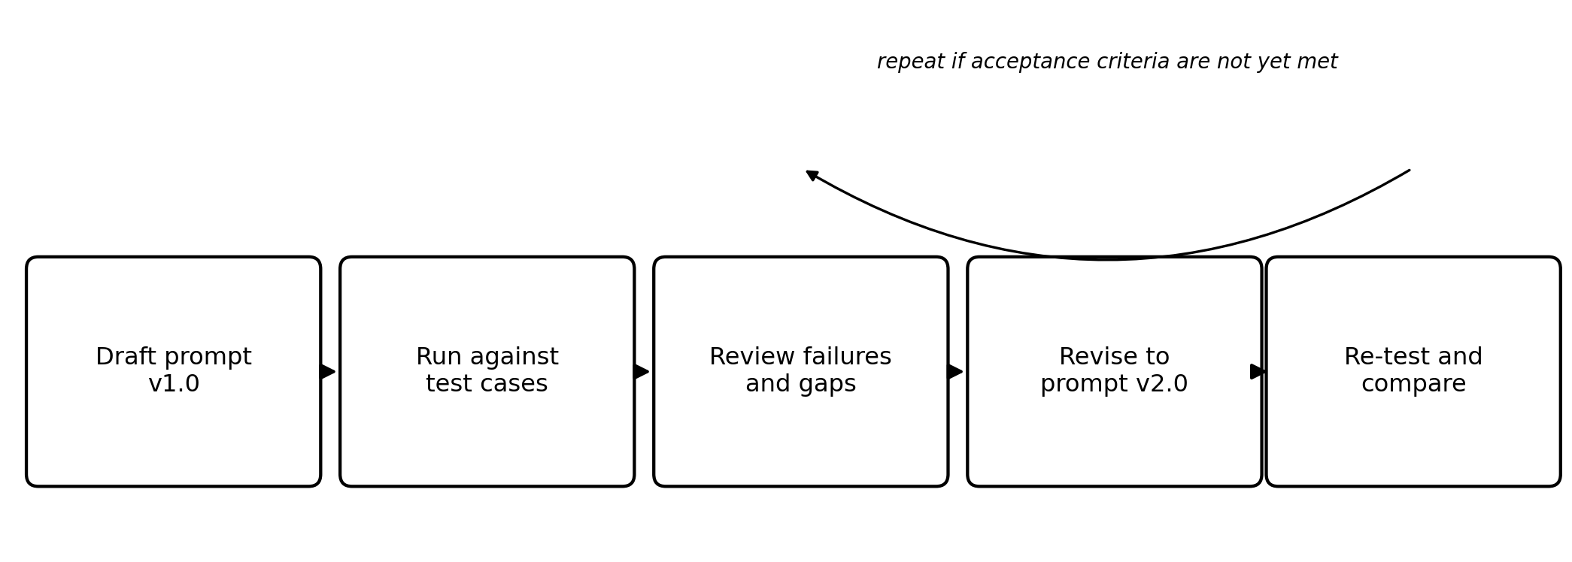

8. Notes for the Next Iteration
Version 2.0 is a real improvement, but it is not the final word. A few things are already on the list for the next round of testing:
- Confirming the JSON output stays valid and parseable across a larger and more varied test set, including documents with unusual formatting or handwritten annotations.
- Checking how the prompt behaves when a checklist requirement is genuinely ambiguous in the source regulation itself, not just when the document is unclear.
- Deciding whether "confidence" should be a free text field like it is now, or a more constrained scale, once there is enough test data to see how the model actually uses it.
These will be carried into the Week 3 evaluation work, once the ten-case prompt evaluation table required for that stage is built out.
.

